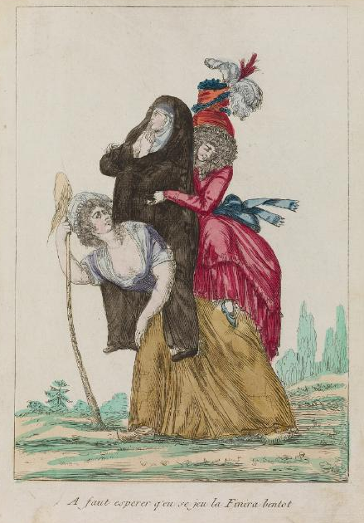

“Have to hope this game will finish her off soon.”
Waddesdon Manor, Rothschild Collection of French Revolution Prints, no. 4232.1.32.64.
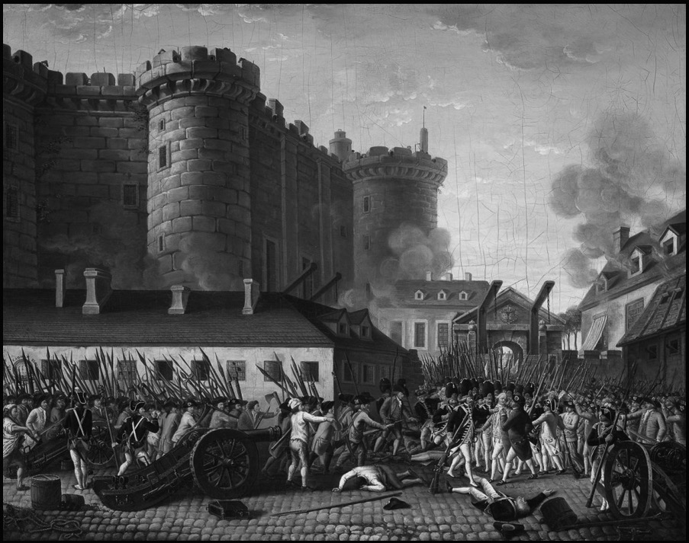

Fall of the Bastille and Arrest of the Governor M. de Launay, 14 July 1789. Artist unknown, painted c. 1789-1791.
National Museum of the Chateau of Versailles, MV 5517.
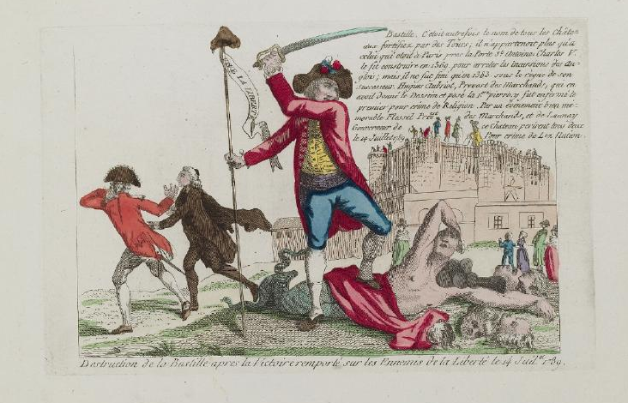
“Destruction of the Bastille after the Victory over the Enemies of Liberty on 14 July 1789.” Artist unknown, 1789.
Waddesdon Manor, Rothschild Collection of French Revolution Prints, no. 4222.10.10.
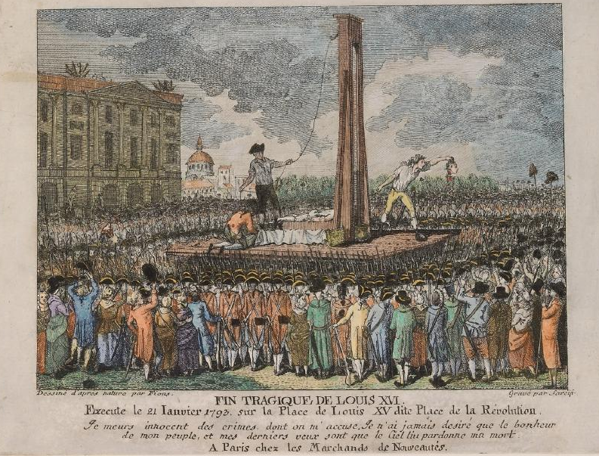

“The Tragic End of Louis XVI, executed January 21, 1793, on Louis XV Place, aka Place of the Revolution.” Artist unknown, possibly created in 1793.
Waddeston Manor, Rothschild Collection of French Revolution Prints, no. 4232.2.35.61.
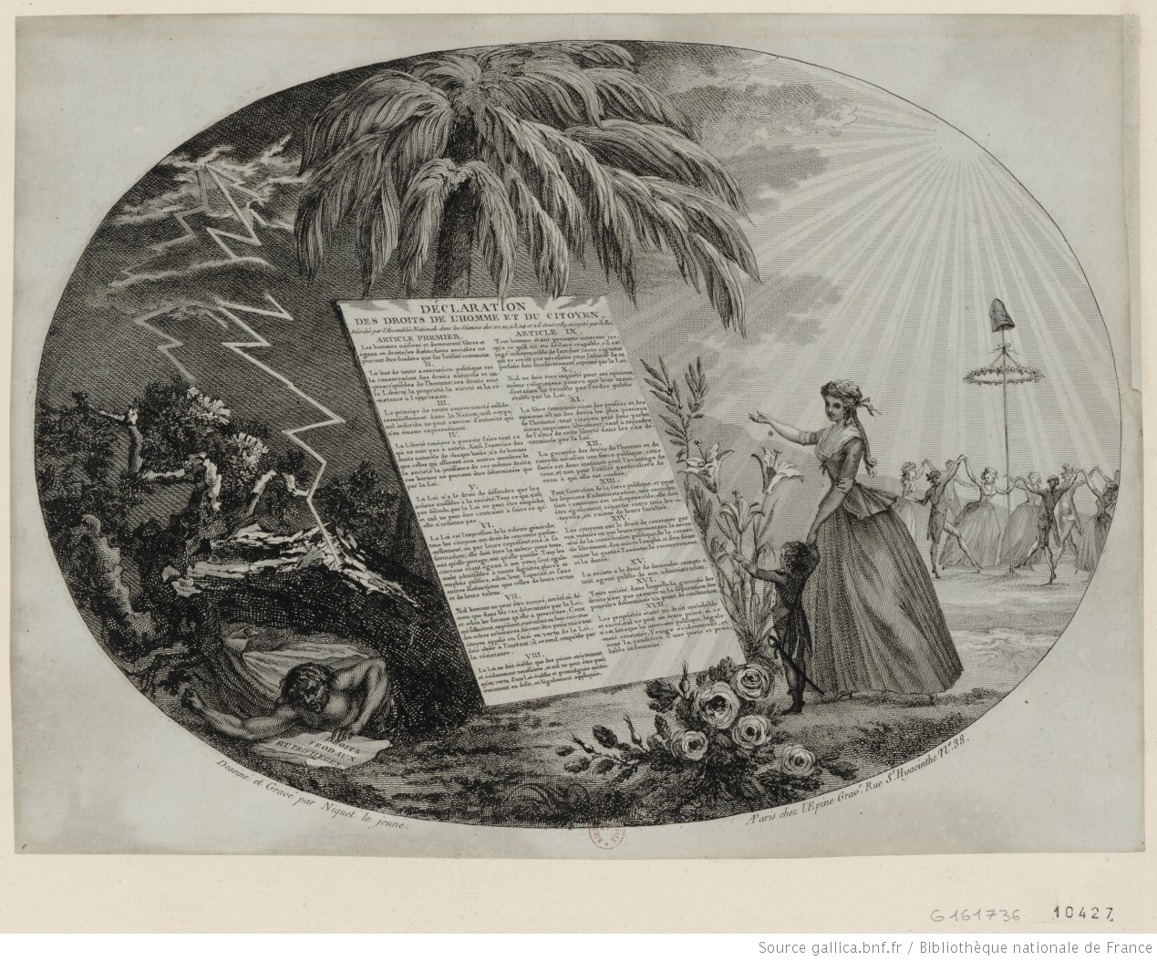
“The Declaration of the Rights of Man and the Citizen.” Image by Niquet le jeune, circa 1789.
Prints & Photographs Department, National Library of France, Hennin Collection, no. 10427.
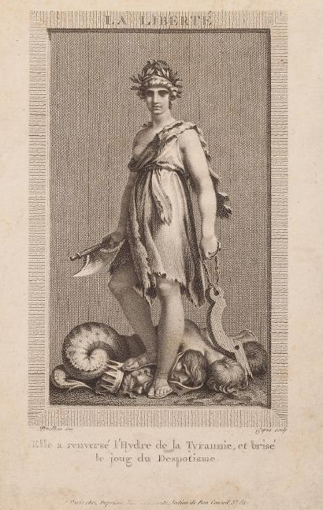
Pierre-Paul Prud’hon, “Liberty. She has overthrown the Hydra of Tyranny and broken the yoke of Despotism,” circa 1794.
Waddesdon Manor, Rothschild Collection of Prints from the French Revolution, no. 4232.2.26.41.

