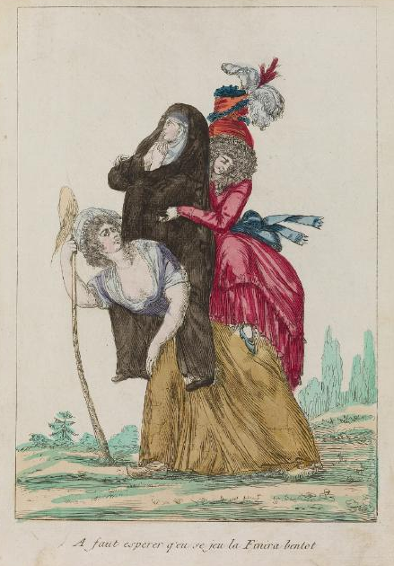

“Have to hope this game will finish her off soon.”
Waddesdon Manor, Rothschild Collection of French Revolution Prints, no. 4232.1.32.64.
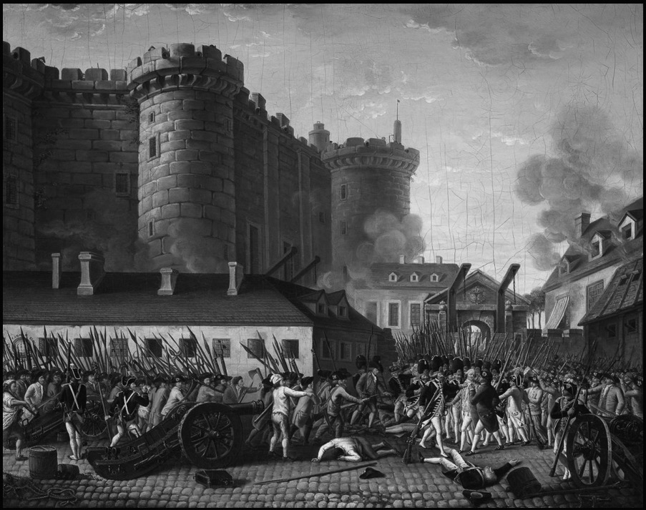

Fall of the Bastille and Arrest of the Governor M. de Launay, 14 July 1789. Artist unknown, painted c. 1789-1791.
National Museum of the Chateau of Versailles, MV 5517.
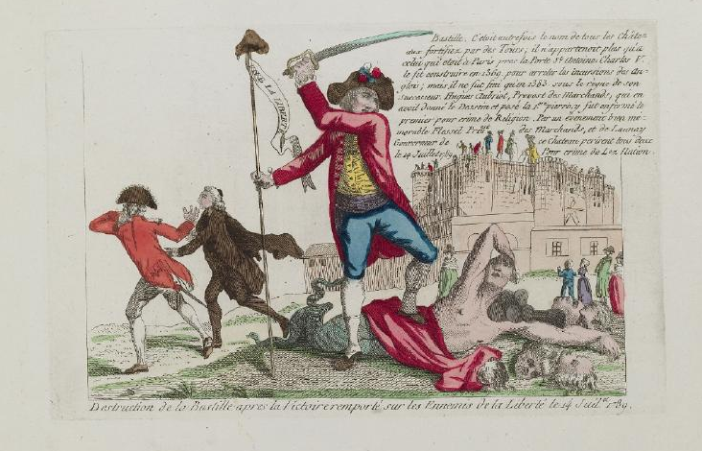
“Destruction of the Bastille after the Victory over the Enemies of Liberty on 14 July 1789.” Artist unknown, 1789.
Waddesdon Manor, Rothschild Collection of French Revolution Prints, no. 4222.10.10.
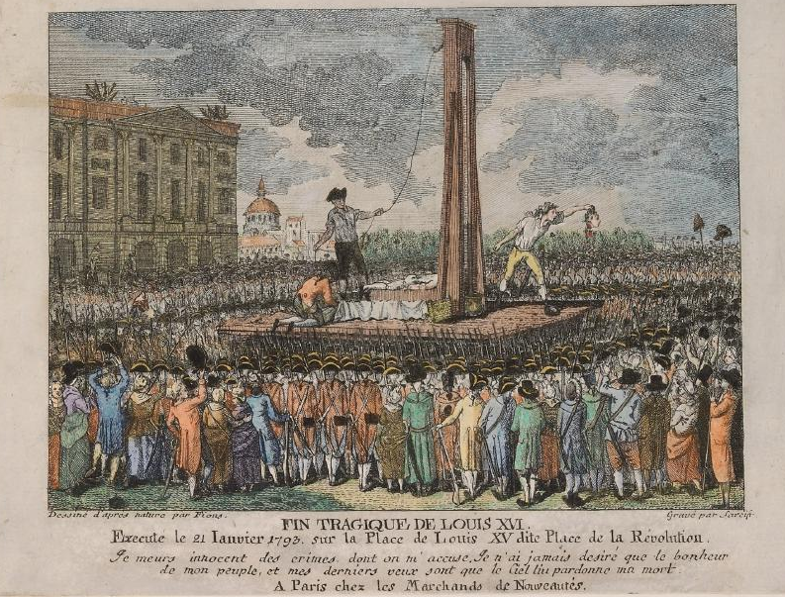

“The Tragic End of Louis XVI, executed January 21, 1793, on Louis XV Place, aka Place of the Revolution.” Artist unknown, possibly created in 1793.
Waddeston Manor, Rothschild Collection of French Revolution Prints, no. 4232.2.35.61.
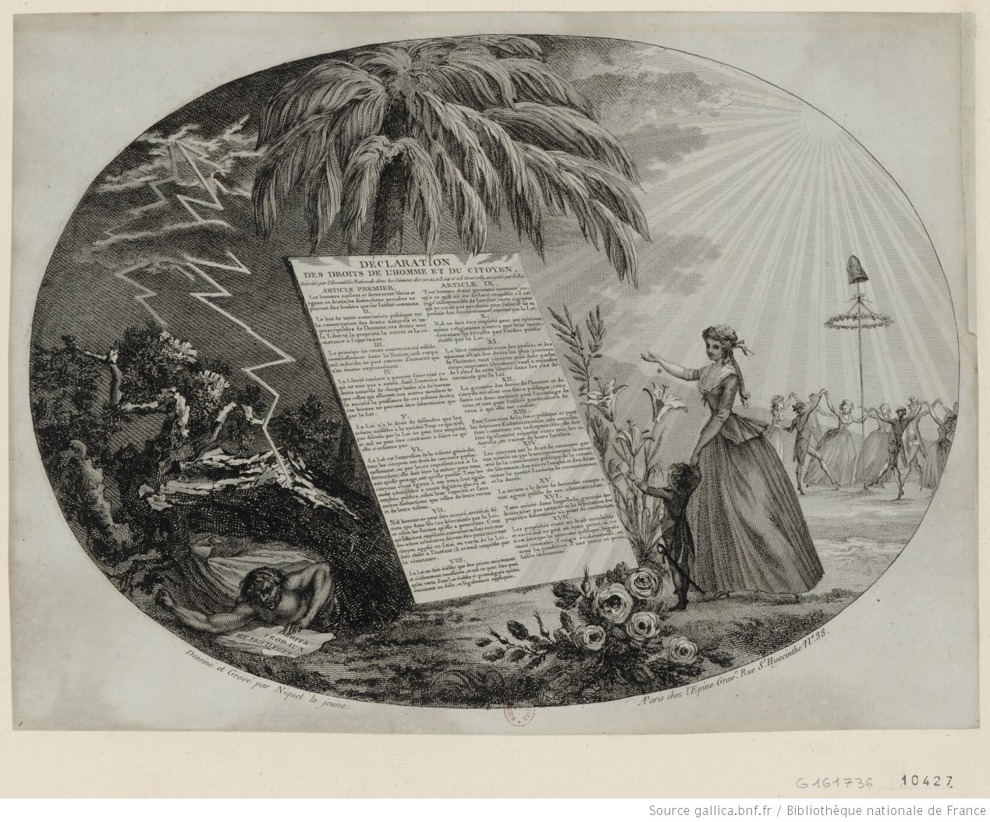
“The Declaration of the Rights of Man and the Citizen.” Image by Niquet le jeune, circa 1789.
Prints & Photographs Department, National Library of France, Hennin Collection, no. 10427.
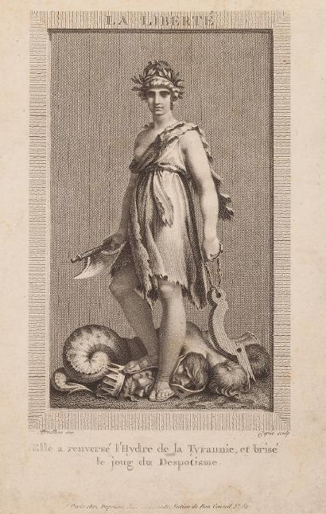
Pierre-Paul Prud’hon, “Liberty. She has overthrown the Hydra of Tyranny and broken the yoke of Despotism,” circa 1794.
Waddesdon Manor, Rothschild Collection of Prints from the French Revolution, no. 4232.2.26.41.
Women’s Petition to the National Assembly, c. October 1789
Sirs,
It is altogether astonishing that, having gone so far along the path of reforms, and having cut down […] a very large part of the forest of prejudices, you would leave standing the oldest and most general of all abuses, the one which excludes the most beautiful and most lovable half of the inhabitants of this vast kingdom from positions, dignities, honors, and especially from the right to sit amongst you.
What! you have generously decreed equality of rights for all individuals; you have made the humble inhabitant of the hovel march alongside the princes and lords of the earth. […]
You have broken the scepter of despotism, you have pronounced the beautiful axiom [that] . . . the French are a free people. Yet still you allow thirteen million slaves shamefully to wear the irons of thirteen million despots! You have divined the true equality of rights—and you still unjustly withhold them from the sweetest and most interesting half among you! . . .
Ah! our masters, […] Dare this very day to alter in our favor the old injustices of your sex; give us the possibility to work like you and with you for the glory and happiness of the French people, and if, as we hope, you consent to share your empire with us, we will no longer owe this precious advantage to our attractiveness; and your own susceptibility to it, but solely to your justice, to our talents, and to the sacredness of your laws.
Source: Rêquete des dames l'Assemblée Nationale (1789), translated by Karen Offen, reprinted in Les Femmes dans le Révolution Française 1789–1794, presentés par Albert Soboul, vol. 1 (Paris, 1982).
Top of Form
Bottom of Form

