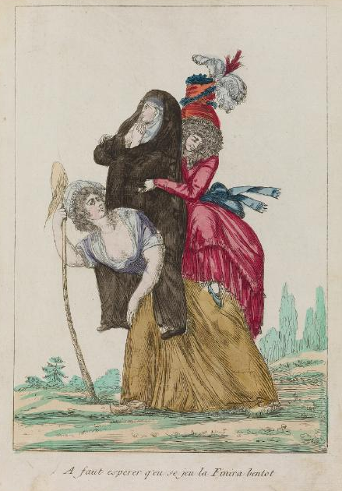

“Have to hope this game will finish her off soon.”
Waddesdon Manor, Rothschild Collection of French Revolution Prints, no. 4232.1.32.64.
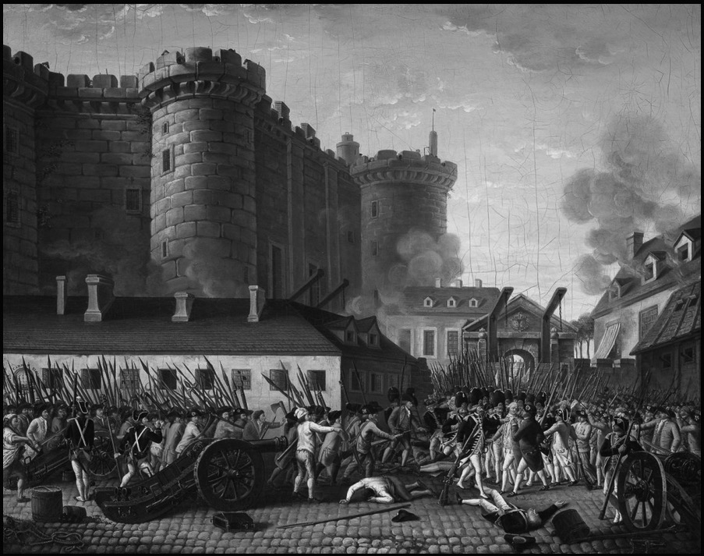

Fall of the Bastille and Arrest of the Governor M. de Launay, 14 July 1789. Artist unknown, painted c. 1789-1791.
National Museum of the Chateau of Versailles, MV 5517.
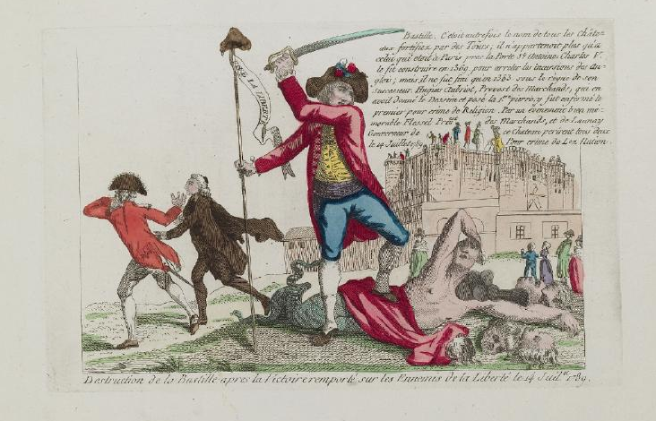
“Destruction of the Bastille after the Victory over the Enemies of Liberty on 14 July 1789.” Artist unknown, 1789.
Waddesdon Manor, Rothschild Collection of French Revolution Prints, no. 4222.10.10.
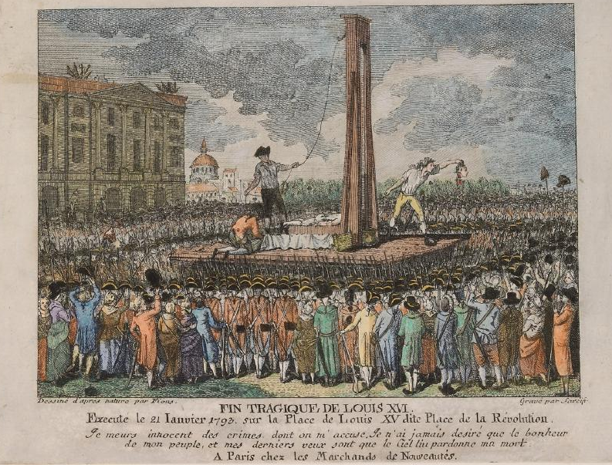

“The Tragic End of Louis XVI, executed January 21, 1793, on Louis XV Place, aka Place of the Revolution.” Artist unknown, possibly created in 1793.
Waddeston Manor, Rothschild Collection of French Revolution Prints, no. 4232.2.35.61.
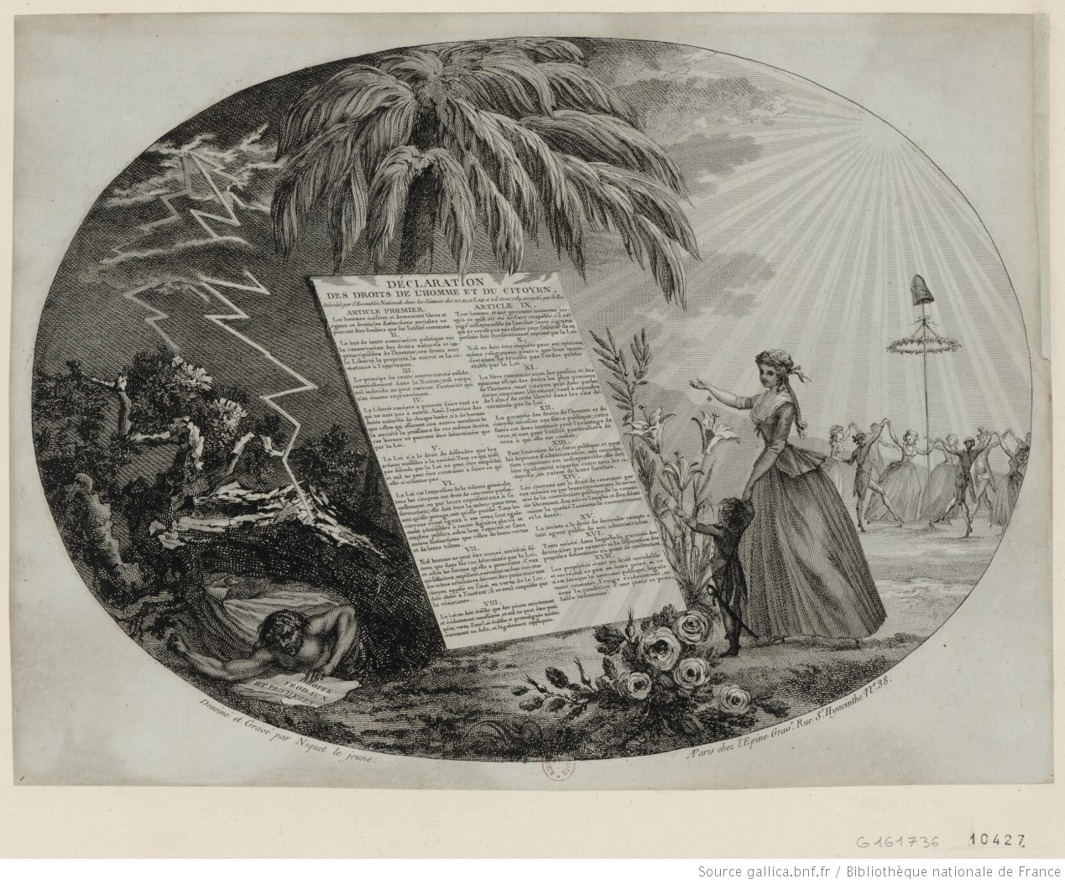
“The Declaration of the Rights of Man and the Citizen.” Image by Niquet le jeune, circa 1789.
Prints & Photographs Department, National Library of France, Hennin Collection, no. 10427.
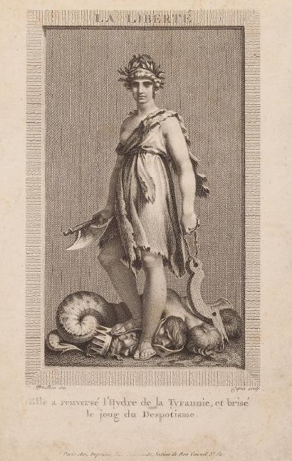
Pierre-Paul Prud’hon, “Liberty. She has overthrown the Hydra of Tyranny and broken the yoke of Despotism,” circa 1794.
Waddesdon Manor, Rothschild Collection of Prints from the French Revolution, no. 4232.2.26.41.
An Anonymous Letter Addressed to M. Mollérat, Saint-Pierre, Martinique, 28 August 1789

Dear Sirs:

General, Intendant, the Government, Advisers, and other individuals, we know that we are free and that you are aware that rebellious people are resisting the orders of the king [to abolish slavery—a false rumor spreading in Martinique, Ed.]. Well, remember that we nègres [blacks] are numerous, and we want to die for this liberty; for we want it and plan to get it at whatever price, even with the use of mortars, cannons, and rifles. Why, for how many hundreds of years, have our fathers been subjected to this fate that still falls on us? Did God create anyone as a slave? The sky and the earth belong to the lord God, along with everything they contain; you have corrupted our ancestors, not only them, but also their descendants. Isn’t this horrible, sirs? It must be believed in truth that you are very inhumane not to be touched with compassion for the suffering that we endure. Even the most barbarous of nations would melt into tears if it knew our misery. I will let you think for a while about how quickly it would seek to abolish such an odious law. But in the end, it is in vain that we seek to convince you by invoking sentiments and humanity, for you have none; but by using blows we will have it, for we see that this is the only way to get anywhere. It will start soon if this prejudice is not entirely annihilated…there will be torrents of blood flowing as powerful as the gutters that flow along our streets.

Sirs,
We have the honor of being
Signed by us, Nègres

Original: Centre des Archives d’Outre-Mer, C8A 89, p. 68. Reprinted in Laurent Dubois and John D. Garrigus, Slave Revolution in the Caribbean, 1789-1804: A Brief History with Documents, New York: Bedford/St. Martin’s, 2006.
Bottom of Form

