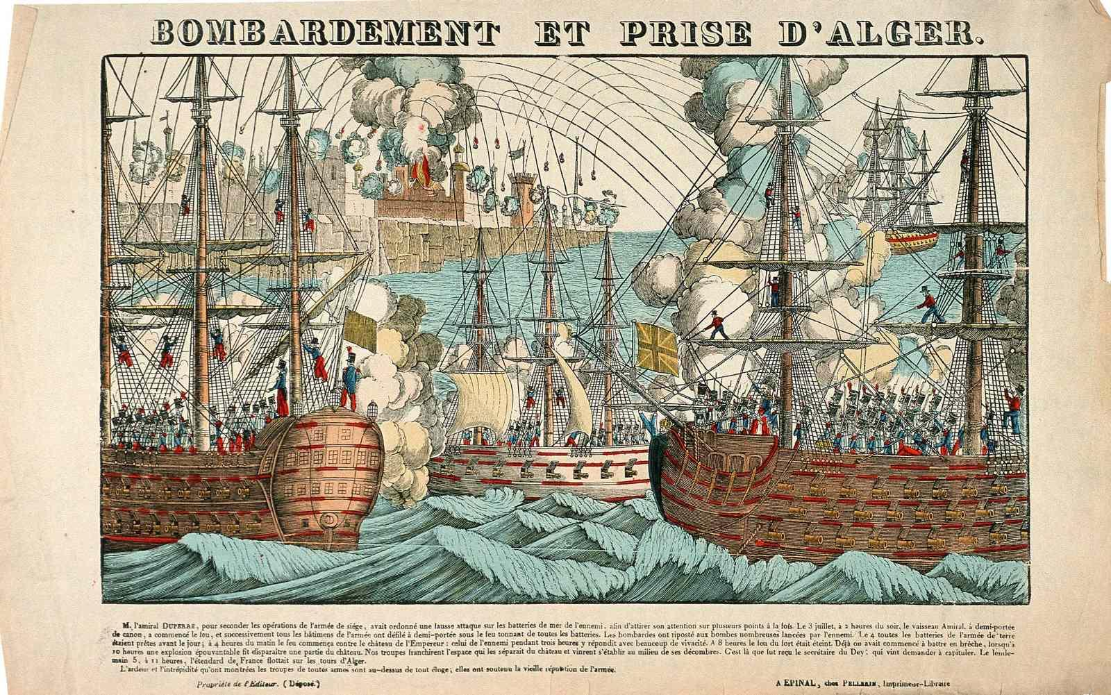

Bombardment & Capture of Algiers, popular engraving by Imagerie d’Epinal, France, 1830.
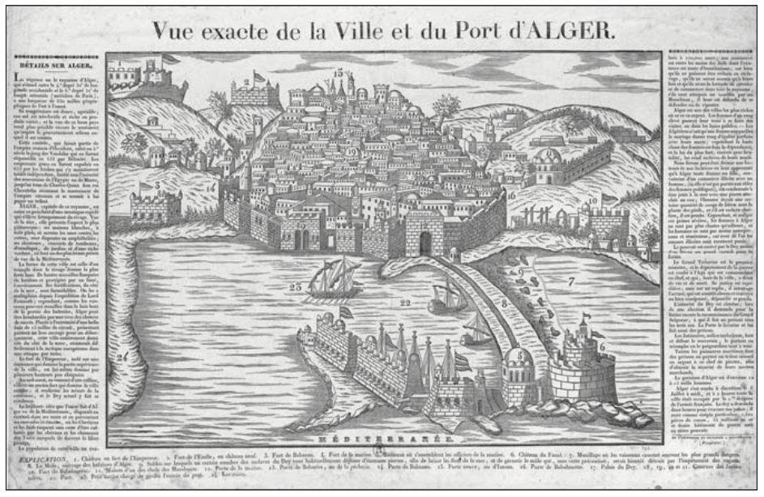

Exact View of the City and Port of Algiers, by Deckherr Brothers, Montbéliard, France, 1830.
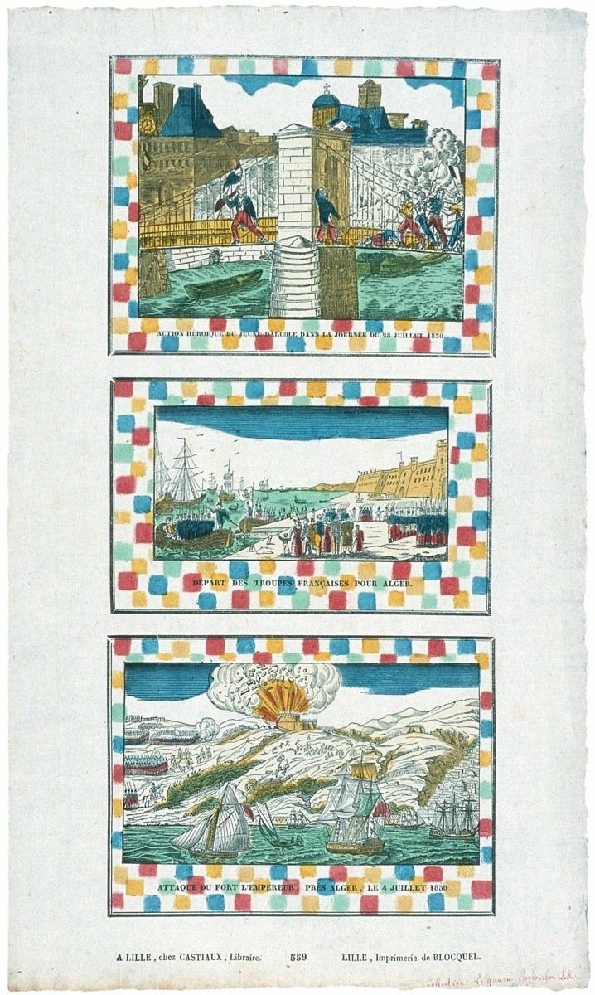

Three popular images, by the Imprimerie Blocquel, Lille, France, 1830:
Heroic scene from the French Revolution of 1830; Departure of the French Troops for Algiers; Attack of the Emperor’s Fort near Algiers, 4 July 1830.

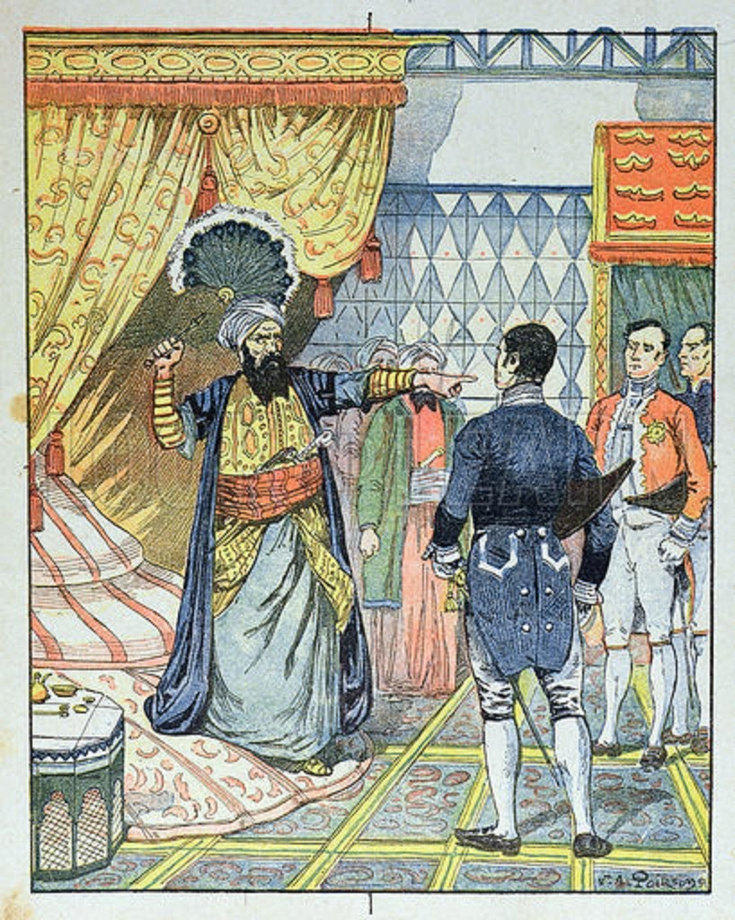

Late 19th-century engraving of the Dey of Algiers striking the French consul with a flyswatter in 1827.

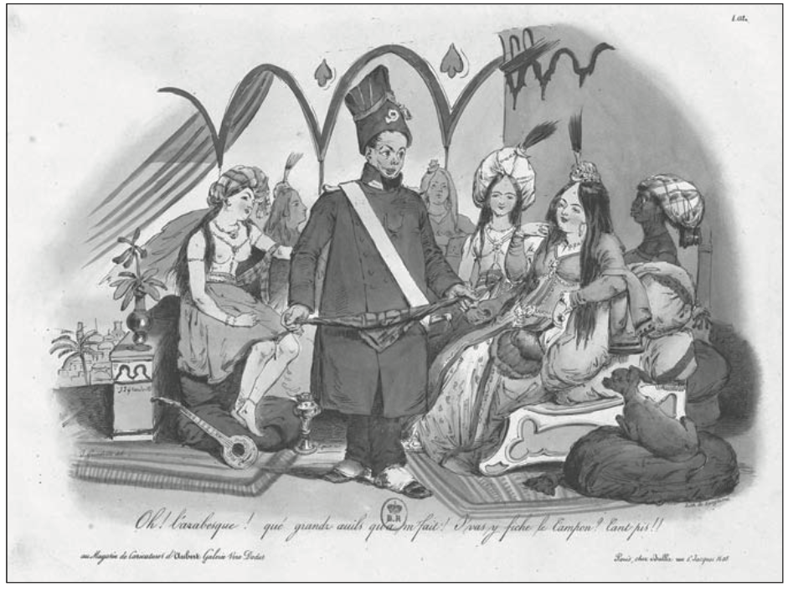
“Oh! The Arabesque! What big eyes you have!”
Popular cartoon from Langlumé lithographers in Paris, August 1830.
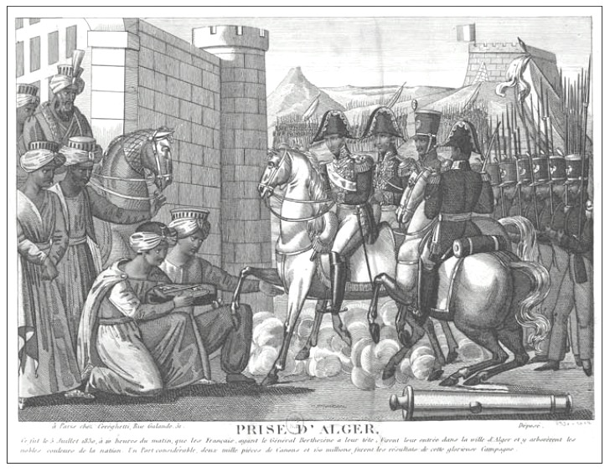
Fall of Algiers, printed in Paris, October 1830.
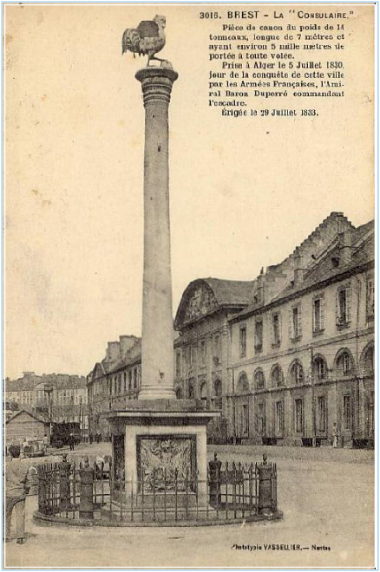

“La Consulaire,” canon captured at Algiers 5 July 1830, erected in Brest, France, 29 Jul 1833.

Oh regrets for Algiers, for its palaces
And for its forts which were so beautiful!
O regrets for its mosques, for the prayers prayed there.
And for their marble pulpits […]
O regrets for Algiers, for its houses
And for its apartments so well-kept!
O regrets for the city of cleanliness
Whose marble and porphyry dazzled the eyes!
The Christians inhabit them, their state has changed!

Poem by ‘Abd al-Qadir about the state of Algiers in 1830
Source: Alf Andrew Heggoy, The French Conquest of Algiers, 1830: An Algerian Oral Tradition (Athens, Ohio, 1986)

