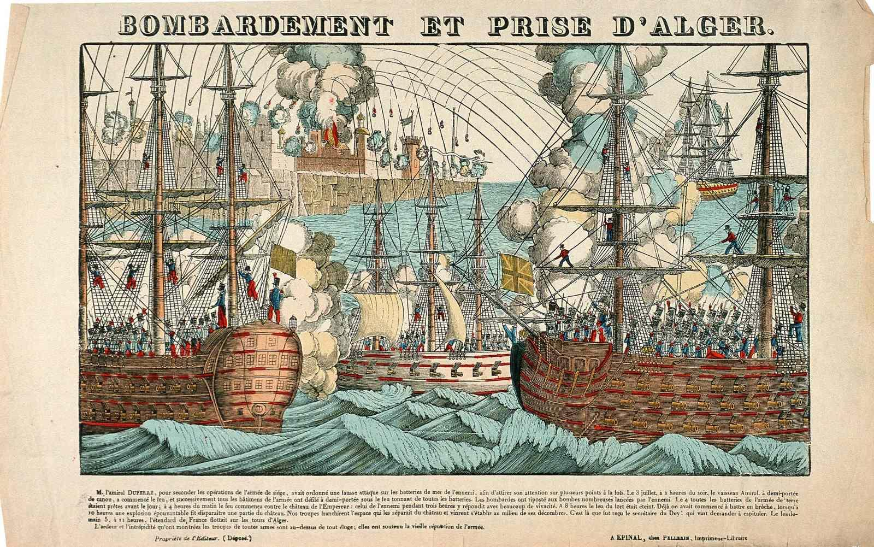

Bombardment & Capture of Algiers, popular engraving by Imagerie d’Epinal, France, 1830.
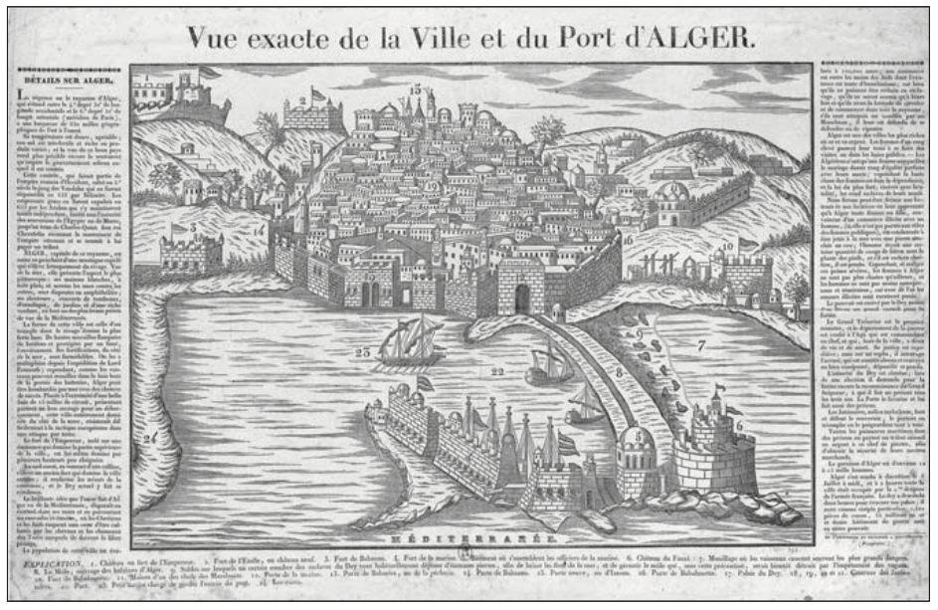

Exact View of the City and Port of Algiers, by Deckherr Brothers, Montbéliard, France, 1830.
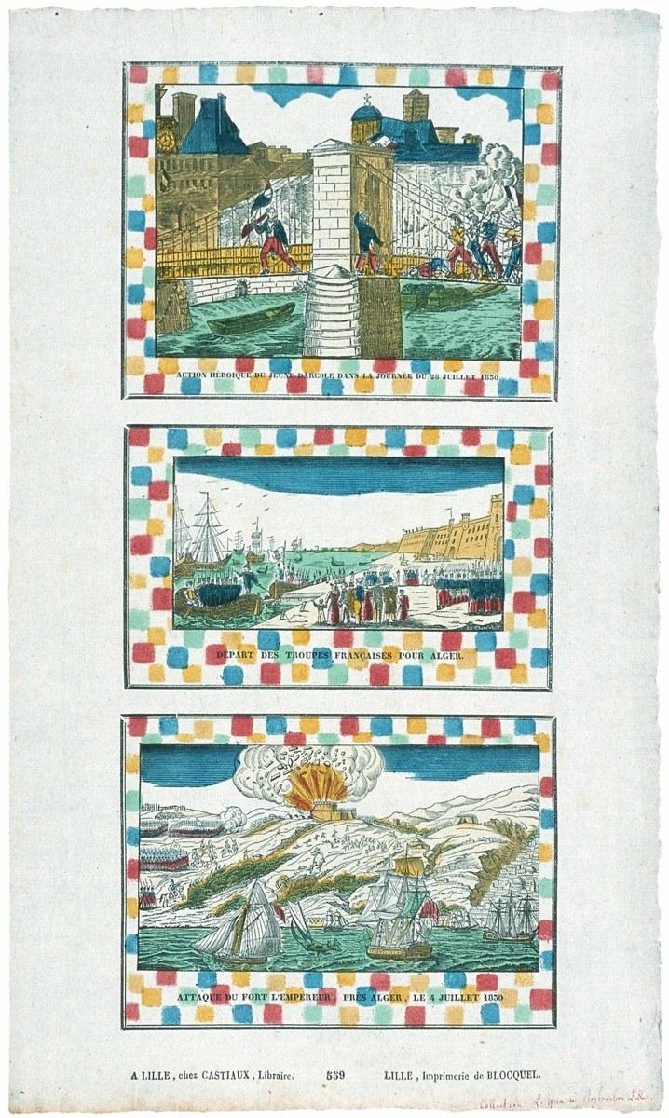

Three popular images, by the Imprimerie Blocquel, Lille, France, 1830:
Heroic scene from the French Revolution of 1830; Departure of the French Troops for Algiers; Attack of the Emperor’s Fort near Algiers, 4 July 1830.

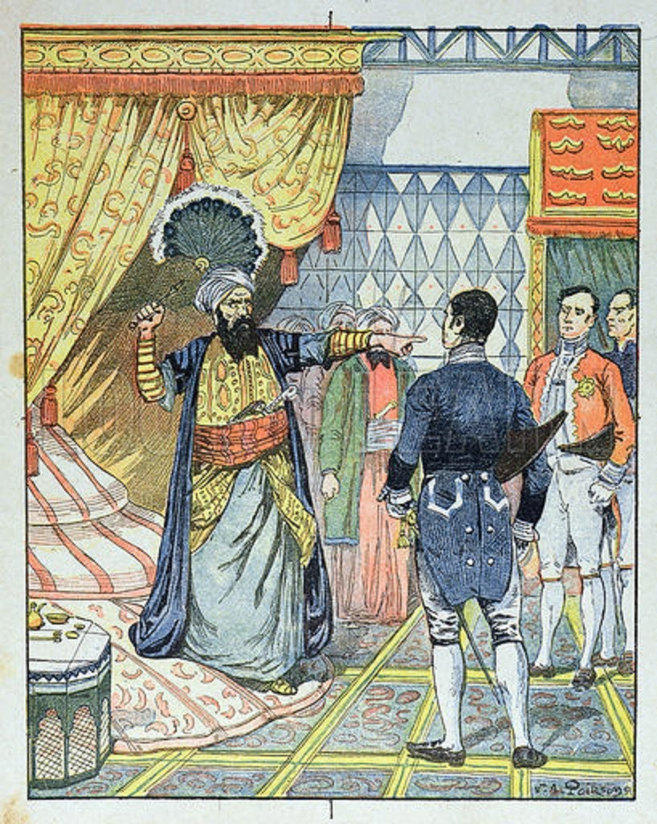

Late 19th-century engraving of the Dey of Algiers striking the French consul with a flyswatter in 1827.

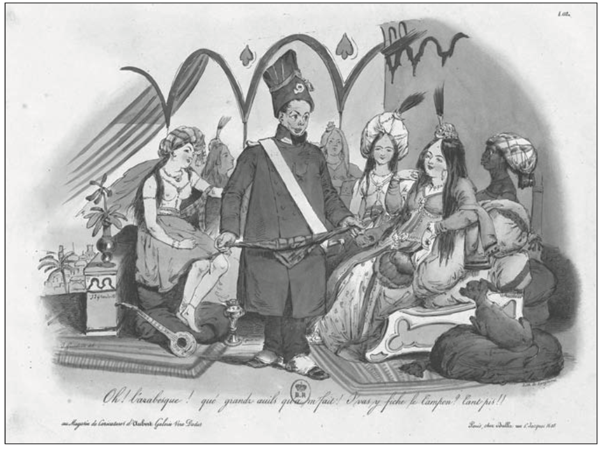
“Oh! The Arabesque! What big eyes you have!”
Popular cartoon from Langlumé lithographers in Paris, August 1830.
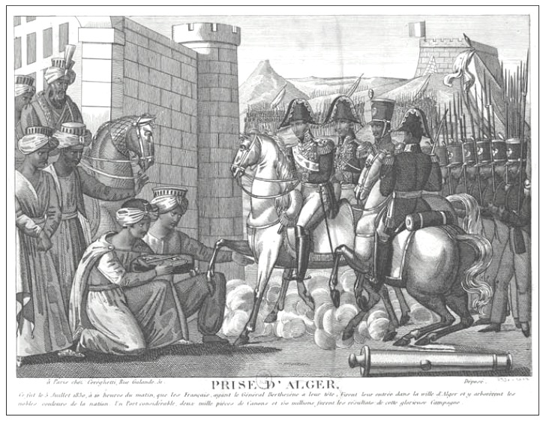
Fall of Algiers, printed in Paris, October 1830
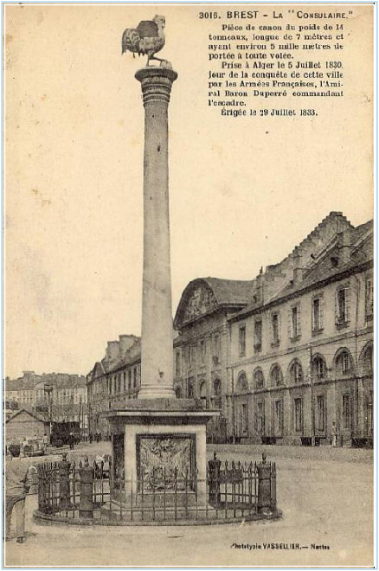

“La Consulaire,” canon captured at Algiers 5 July 1830, erected in Brest, France, 29 Jul 1833.

What, ultimately, lies behind this expedition?

The continuation of a system of illusions that has, for eight months, been pushing France to the end of the abyss. There are bad ministers, without a majority in the Chambers, without a majority in the electoral colleges, who naively think to escape their fate with noise and smoke! There is a malevolent thought, insulting to the army; because they dream perhaps of blinding, with promotions, pensions and honors, its respect for our laws and its loyalty to the constitutional throne. […] There is, finally, the insane hope of turning a victory over Algiers into a victory over our liberties, and to turn the glory they hope to acquire into a means of corruption and violence.

Journal des Débats (Paris), 17 May 1830.

