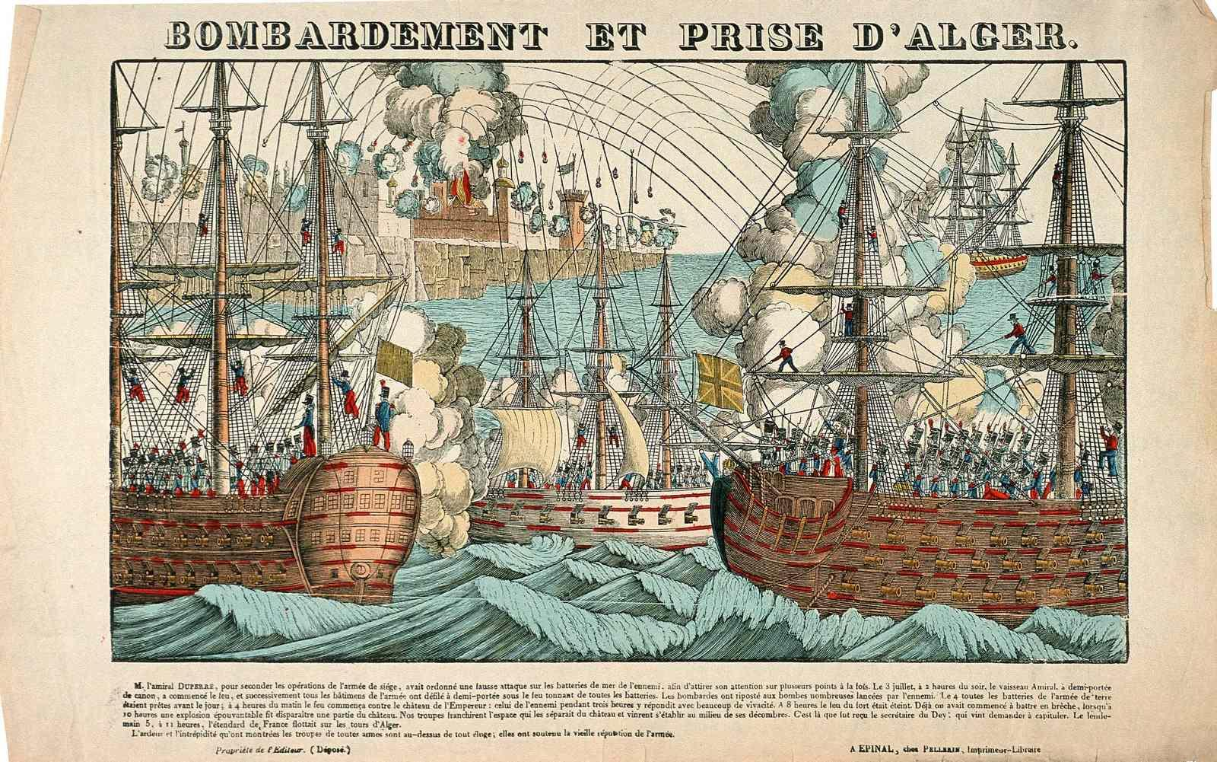

Bombardment & Capture of Algiers, popular engraving by Imagerie d’Epinal, France, 1830.
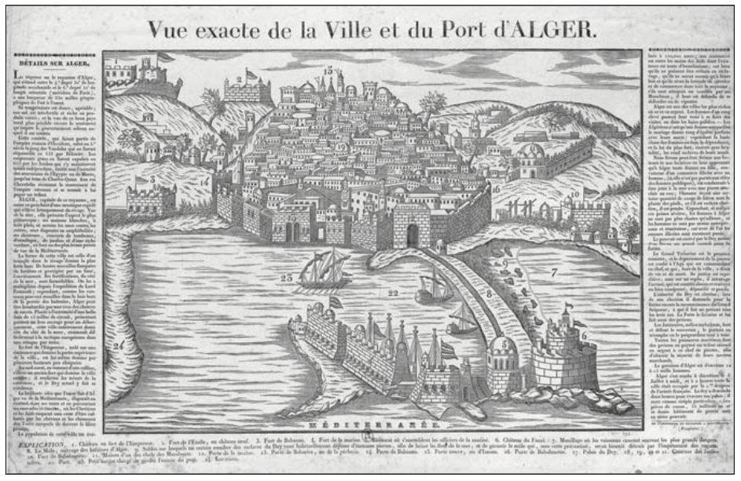

Exact View of the City and Port of Algiers, by Deckherr Brothers, Montbéliard, France, 1830.
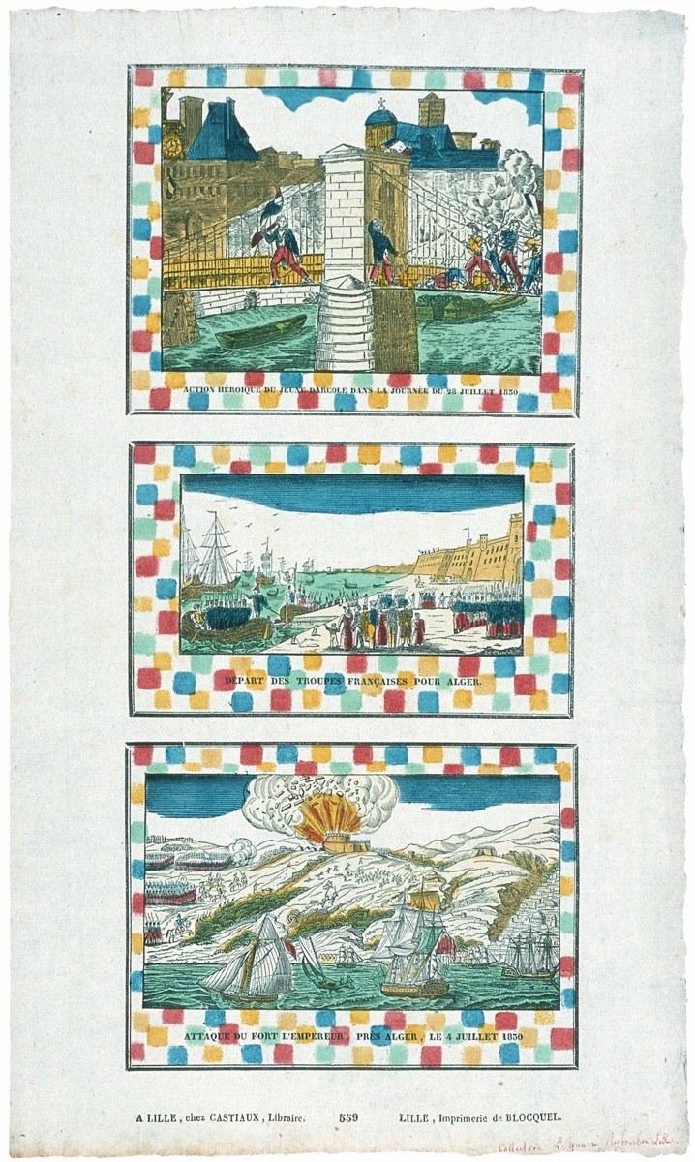

Three popular images, by the Imprimerie Blocquel, Lille, France, 1830:
Heroic scene from the French Revolution of 1830; Departure of the French Troops for Algiers; Attack of the Emperor’s Fort near Algiers, 4 July 1830.

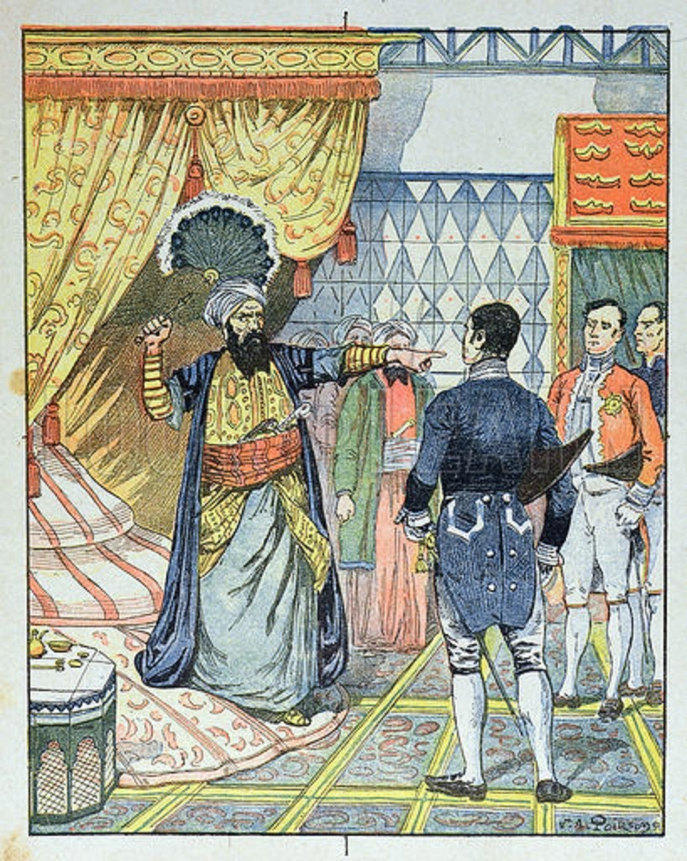

Late 19th-century engraving of the Dey of Algiers striking the French consul with a flyswatter in 1827.

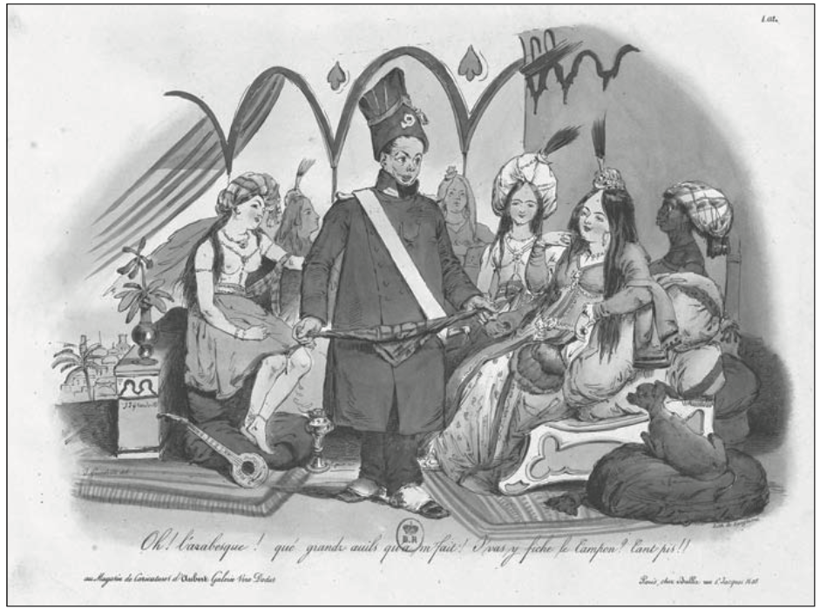
“Oh! The Arabesque! What big eyes you have!”
Popular cartoon from Langlumé lithographers in Paris, August 1830.
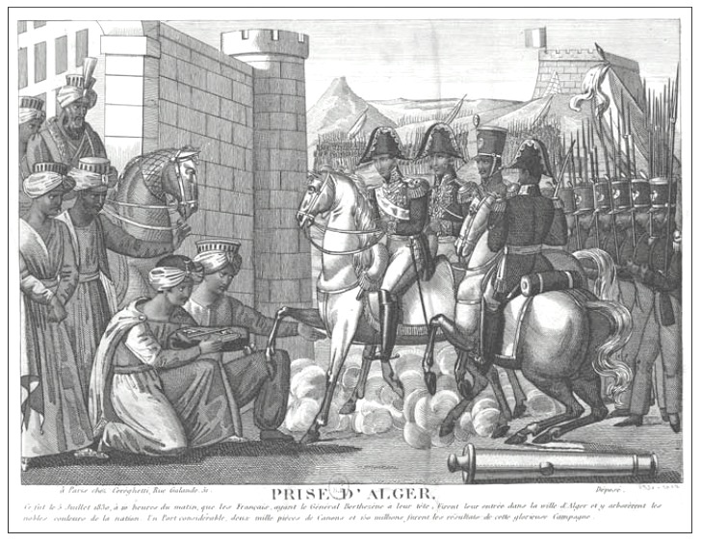
Fall of Algiers, printed in Paris, October 1830
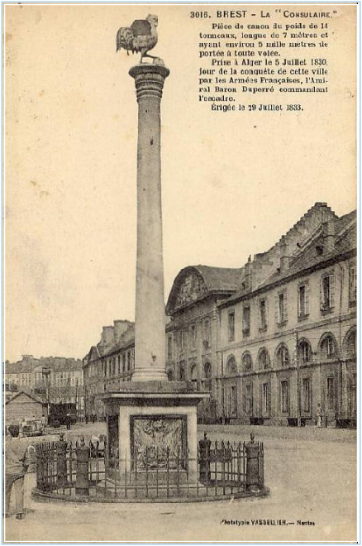

“La Consulaire,” canon captured at Algiers 5 July 1830, erected in Brest, France, 29 Jul 1833.

